MARKING GUIDE FOR SECTION ONE
Question 1 [1, 1, 1 = 3 marks]

The formula
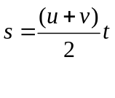
gives the distance s metres , travelled by an object that begins with an initial (starting) speed of u metres per second and that finishes with a final speed of v metres per second, for t seconds.

- Find s given u = 0, v = 60 and t = 10.
s = (0 + 60) × 10
2
s = 300 m ✓

- Find t given s = 140, u = 10 and v = 30.
140 = (10 + 30) × t
2
140 = t
20
t = 7 seconds ✓

- What was the initial speed of an object that travelled 120 metres in 15 seconds and had a final speed of 12 metres per second?
120 = (u + 12) ×15
2
120 × 2 = u + 12
15
u = 16 -12
u = 4 m/s ✓

Question 2 [1, 1, 2, 2 = 6 marks]
Solve the following equations:-

a)

14g - 3g = -20 – 2
11g = -22 → g = -2 ✓

c)
10m - 15 - 3m = 9 - 12 + 3m
10m - 3m - 3m = 15 -3 ✓
4m = 12
m = 3 ✓

b) 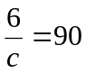
6 = c → c = 1
90 15 ✓
d) 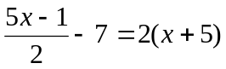
5x -1 = 2x + 10 + 7
2
5x -1 = (2x + 17) x 2✓
5x -4x = 34 + 1
x = 35 ✓

Question 3 [6, 2, 1 = 9 marks]

- Determine the equation of each line shown below.
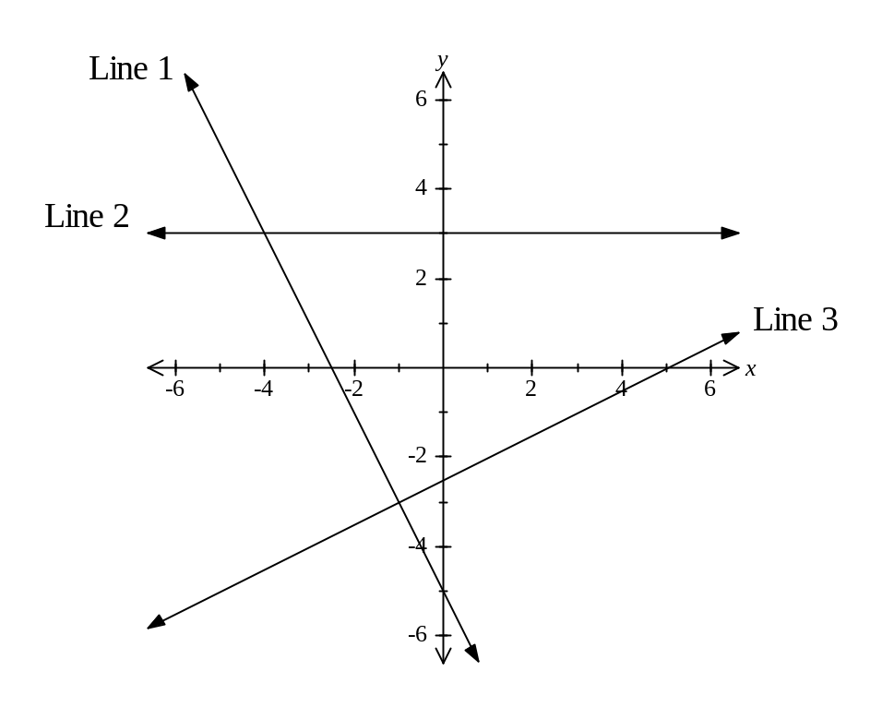
Line 5
Line 6
Line 4

Line 1 - y= -2x -5 ✓ Line 4 - x= 5 ✓

Line 2 - y=3 ✓ Line 5- y = x + 4 ✓

Line 3 - y=½x -2½ ✓ Line 6 - y = -⅜x + 1½ ✓

- Find the gradient, the x - intercept and the y- intercept of the line x - 2y = 8.
x - 2y = 8
y = 8 – x
-2
y = ½ x – 4 ✓✓

- Is the point (1⋅5, -4) on the line whose equation is 6x - y = 12.

Explain why / why not.
When x = 1.5 and y =-4

6 × 1.5 - - 4 = 12
9 + 4 ≠ 12 ✓
Therefore the point (1.5, -4) does not lie on the line 6x - y = 12
Question 4 [4, 2 = 6 marks]

The temperature at mid-day at a particular location was recorded on every day of a particular month. The temperatures were recorded to the nearest degree Celsius and the data was then grouped to give the table below.

Mid –day Temperature (ºC) | 15→19 | 20→24 | 25→29 | 30→34 | 35→39 | 40→44
Frequency  (Number of Days) | 2 | 6 | 10 | 7 | 4 | 1

- On the axes below, draw a fully labelled histogram of the data given in the table above.

Frequency (days) Mid-day Temperature on a particular month
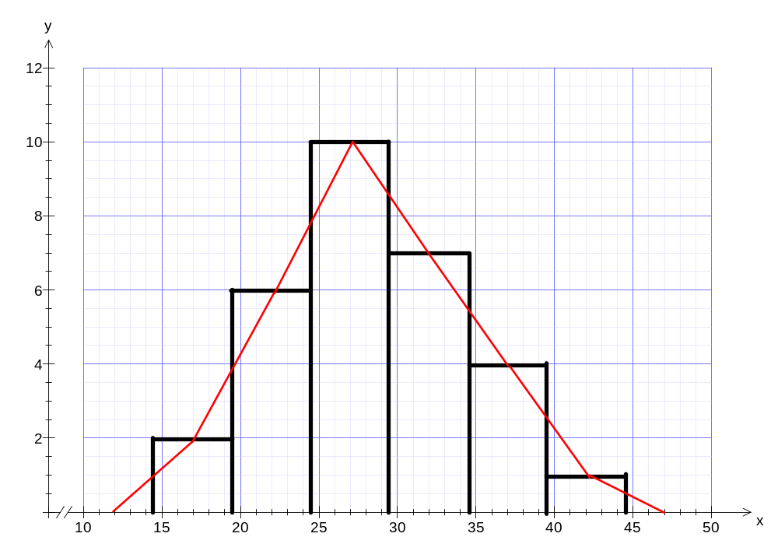
Mid-Day Temperature (º Celsius)

✓✓ Graph/accuracy ✓ Title ✓✓ Labels
-1 for gaps -1 for not 0.5 more and less for each range

- On the histogram, sketch the frequency polygon

✓ Middle of columns ✓ for joining to x-axis
Question 5 [2, 2, 2, 2 = 8 marks]

Show the following transformations on the axes below:-

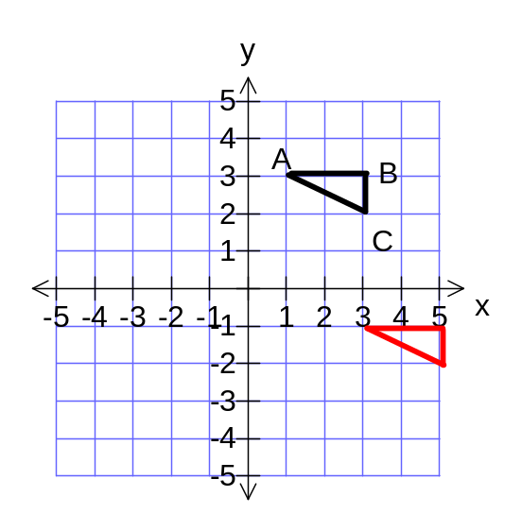  a) Translate ABC 4 units down✓  and 2 units right ✓ | 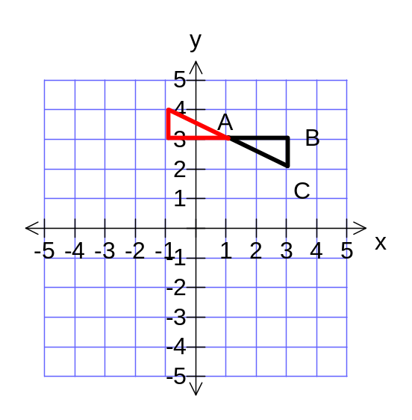  b)Rotate ABC 180º clockwise ✓  about A✓
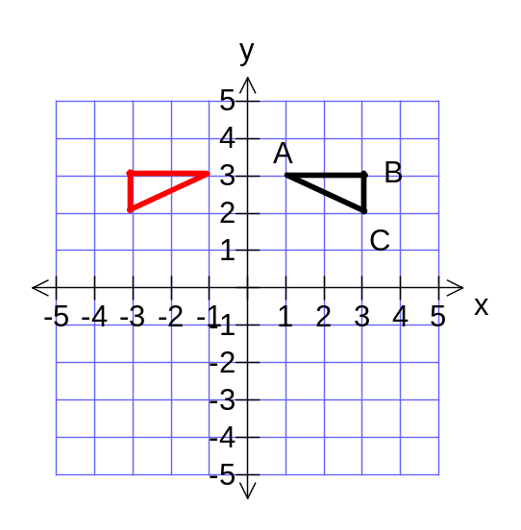  c) Reflect ✓ABC in the Y axis ✓ | 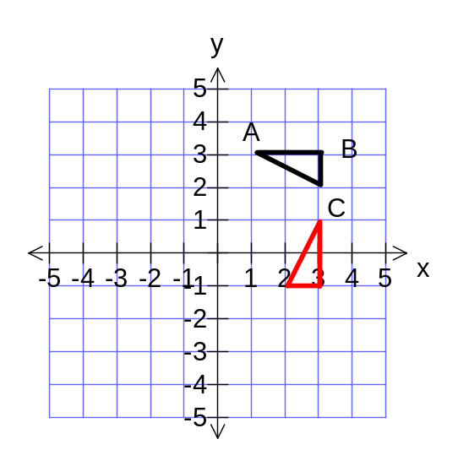  d) Rotate ABC 90º clockwise ✓  about the point (1, 1). ✓

Question 6 [3 marks]

The costs to a book publishing company for publishing a book comprise of a cost for typesetting - which is a fixed cost (it is a constant amount - irrespective of the number of books produced) plus a variable cost (which will vary, depending on the number of books produced). The company calculated that to produce 20 000 copies of a particular book the cost would be $ 275 000 whilst to produce 23 000 copies the cost would be $ 311 000.

Calculate the fixed cost, variable cost and the cost for 15000 books?

20000 x + b = 275000 (1) (✓ if wrong
23000 x + b = 311000 (2) answers)

From (1) substitute b = 275000 – 20000x into (2)

Then (2) becomes 23000x + (275000 – 20000x) = 311000
3000x = 311000 - 275000
3000x = 36000
x = 12 ✓
Substitute x = 12 into (1) 20000 × 12 + b = 275000
b = $35000 ✓

Therefore when producing 15000 books

(12 × 15000) + 35000 = $215000 ✓

Question 7 [1, 1, 1, 1, 1 = 5 marks]

Scores on a test for a class of students:-

Score | 3 | 4 | 5 | 6 | 7 | 8 | 9 | 10
Frequency | 0 | 1 | 5 | 5 | 4 | 4 | 4 | 2

Answer the following questions for the above set of scores:-

- How many students are in the class? 25 ✓

- What is the mode? 5 and 6 ✓for both

- What is the median? 7 ✓

- What is the mean? 7 ✓
- What percentage of students scored 7 or less? × 100% = 60% ✓

